TECHNICAL REPORT

Please refer README.txt for how to run and generate output.

DETAILED TECHNICAL EXPLANATION OF SOURCE CODE :

First, the code will take the input through command line (if specified).

INQ

Then for INQ, there will be N queues at input port which is implemented using vector of queues of struct.
A packet is implemented using structure, in which input_port, output_port and start_time are stored.

All the three phases will run for each timeslot.

In phase 1,
the packets will be generated in the input queues according to the packet generation probability for the random output port. If buffer size gets increased over B, then the packets are dropped.

In phase 2,
the packets are scheduled from input port to output port. If there is no contention for a output port, the packet is selected for transmission. If there is contention for some output port, one among those packets is selected for the transmission randomly.

In phase 3,
the selected packets are transmitted and deleted from input queues and following things are calculated;
1. packet delays
2. link utilisation
3. total packets transmitted

KOUQ

For KOUQ, there will be N queues at input port and N queues at output ports, which are implemented using vector of queues of struct.
A packet is implemented using structure, in which input_port, output_port and start_time are stored.

All the three phases will run for each timeslot.

In phase 1, similar to INQ, the packets will be generated in the input queues according to the packet generation probability for the random output port.

In phase 2, the packets are scheduled from front of all input queues to output port.
If there are less than K packets generated for a output port, these packets are selected for transmission and put in the output queue.
If there are more than K packets for some output port, only K packets are selected from them for the tranmission and put in the output queue and remaining packets are dropped.

In phase 3, the packets are selected from the front of all the output queues and
the packets are transmitted and following things are calculated,
*packet delays
*link utilisation
*total packets transmitted
*KOUQ drop probability

ISLIP

The ISLIP part will be submitted later.

PERFORMANCE OF SCHEDULING SCHEMES

INQ : for B=2

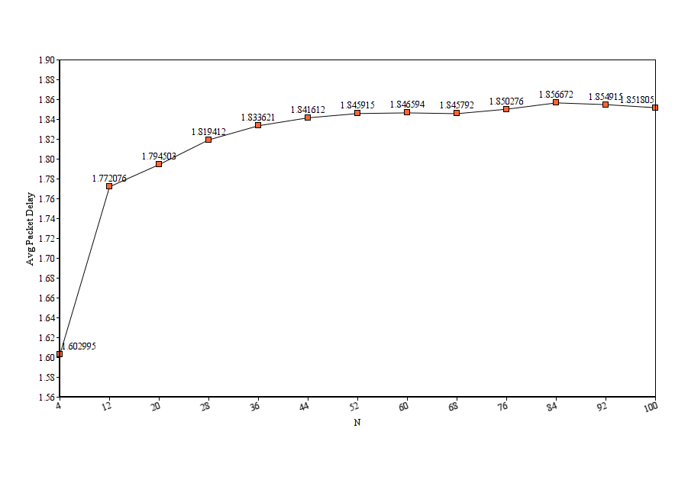

The average packet delay is increased with the increase in number of switch ports, but it becomes almost constant with higher values of N.

For N=4, avg packet delay=1.60
For N=100, avg packet delay=1.85

INQ : for B=2

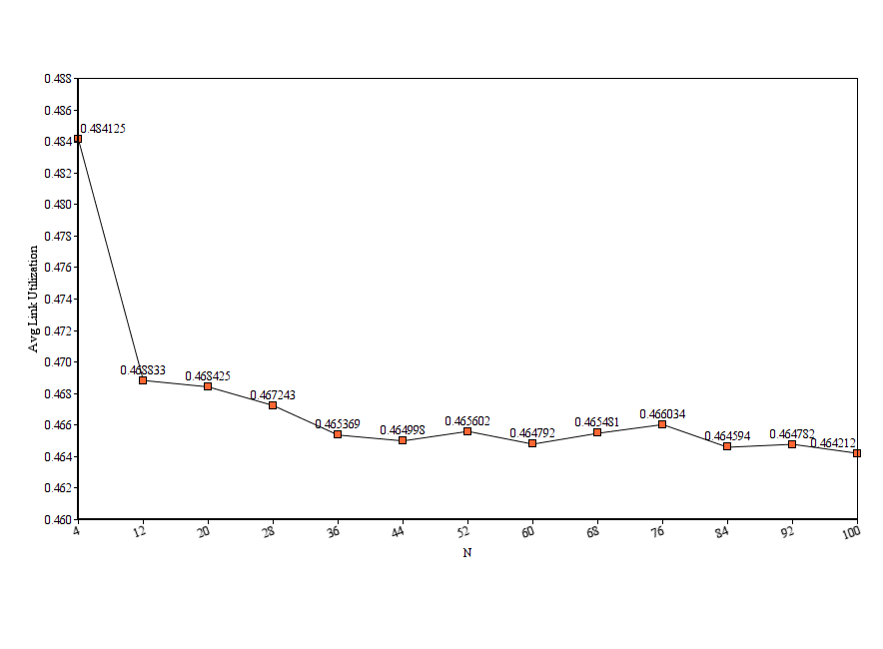

The average link utilization is decreased with the increase in number of switch ports,
but again for the higher values of N, the relative change is very little.

For N=4, avg link utilization=0.48
For N=100, avg link utilization=0.46

INQ: for B=3

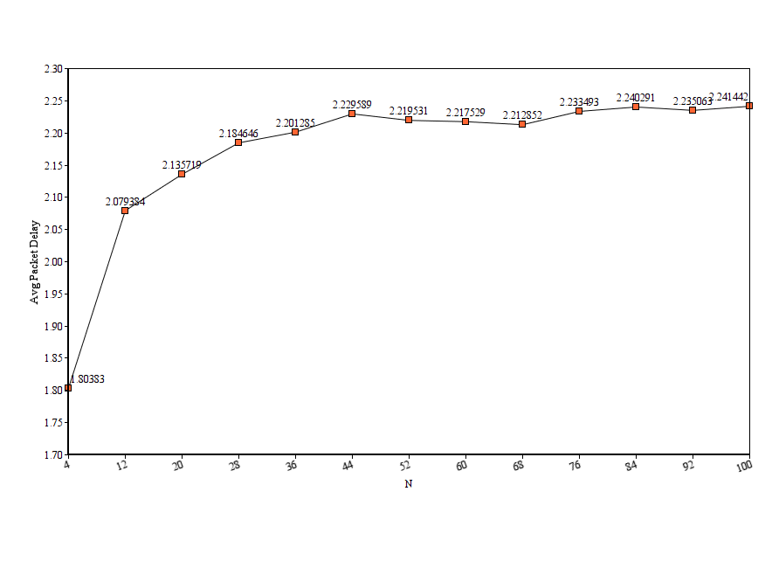

Here, the buffer size is changed from 2 to 3.
The average packet delay is increased with the increase in number of switch ports, but it becomes almost constant with higher values of N.

For N=4, avg packet delay=1.80
For N=100, avg packet delay=2.41

For higher values on N, the avg packet delay is increase as compared to that in B=2.

INQ: for B=3

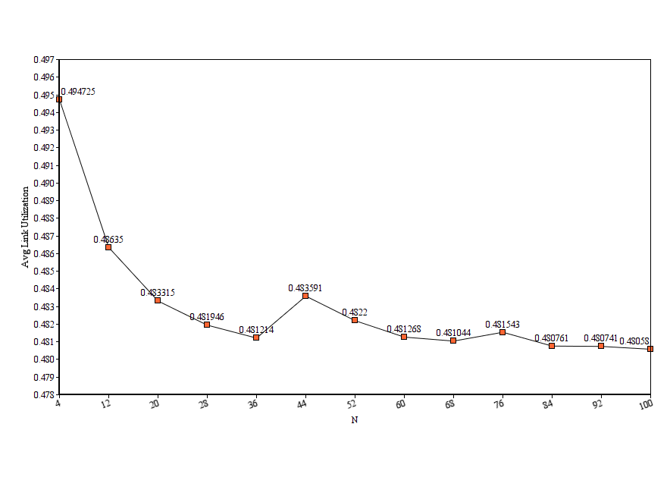

Here, the buffer size is changed from 2 to 3.
The average link utilization is decreased with the increase in number of switch ports,
but again for the higher values of N, the relative change is very little.

For N=4, avg link utilization=0.49
For N=100, avg link utilization=0.48

Not much difference is seen as compared to that in B=2.

INQ: for B=4

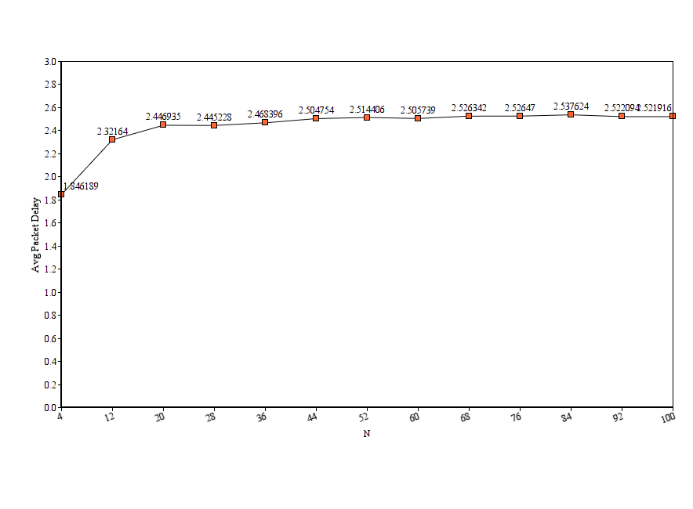

Here, the buffer size is changed from 3 to 4.
The average packet delay is increased with the increase in number of switch ports, but it becomes almost constant with higher values of N.

For N=4, avg packet delay=1.84
For N=100, avg packet delay=2.52

Not much difference is seen as compared to that in B=2.

INQ: for B=4

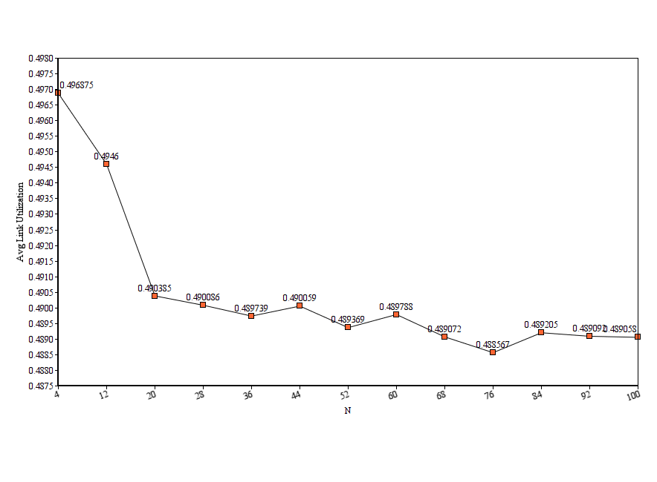

Here, the buffer size is changed from 3 to 4.
The average link utilization is decreased with the increase in number of switch ports,
but again for the higher values of N, the relative change is very little.

For N=4, avg link utilization=0.49
For N=100, avg link utilization=0.48

Not much difference is seen as compared to that in B=3.

KOUQ: for B=2

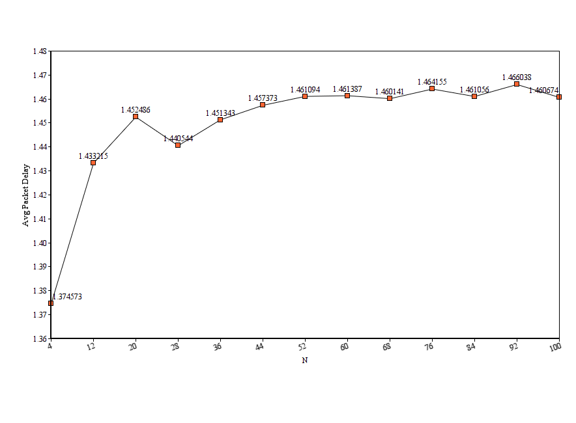

The average packet delay is increased with the increase in number of switch ports, but it becomes almost constant with higher values of N.

For N=4, avg packet delay=1.37
For N=100, avg packet delay=1.45

KOUQ: for B=2

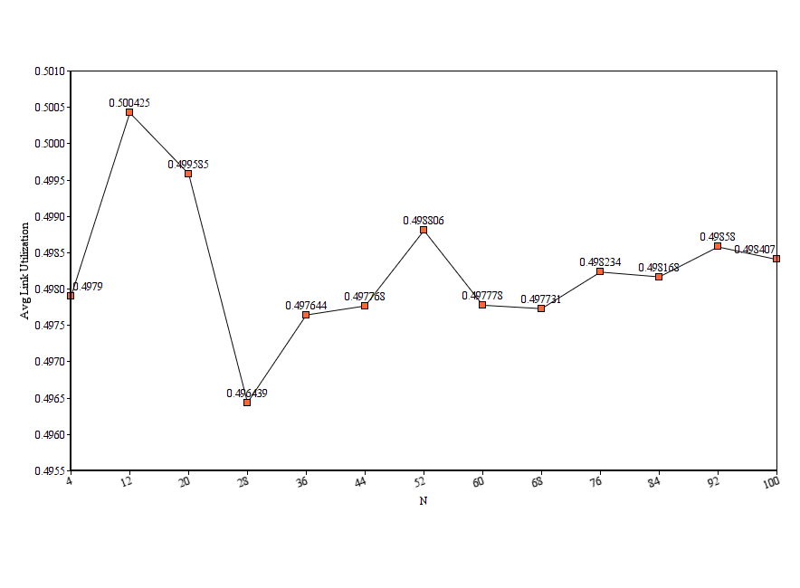

Here, for B=2, the average link utilization is more or less constant.
The graph shows spike because of less scale on Y axis.

For N=4, avg link utilization=0.49
For N=100, avg link utilization=0.49

It’s almost constant.

KOUQ: for B=3

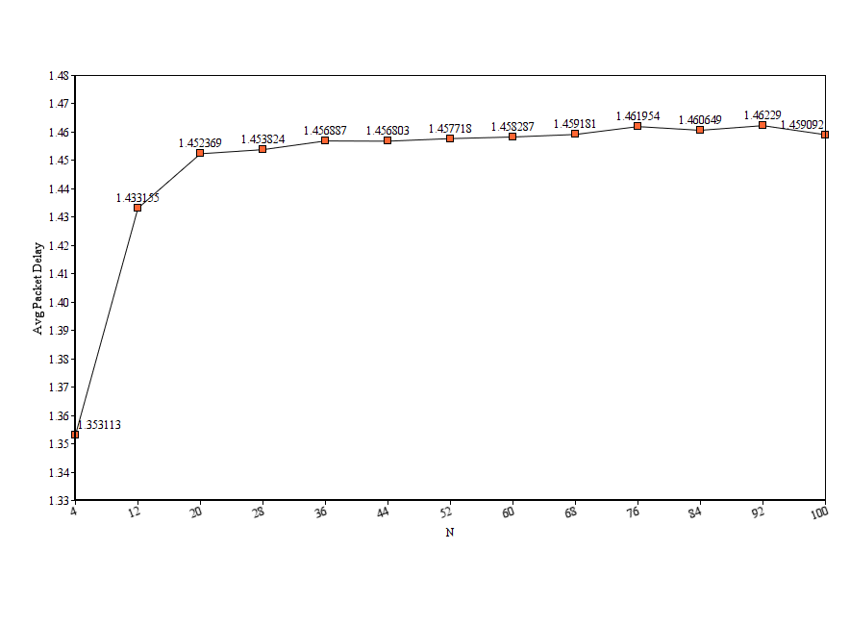

Here, the buffer size is changed from 2 to 3.
The average packet delay is increased with the increase in number of switch ports, but it becomes almost constant with higher values of N.

For N=4, avg packet delay=1.35
For N=100, avg packet delay=1.45

Not much difference is seen as compared to that in B=2.

KOUQ: for B=3

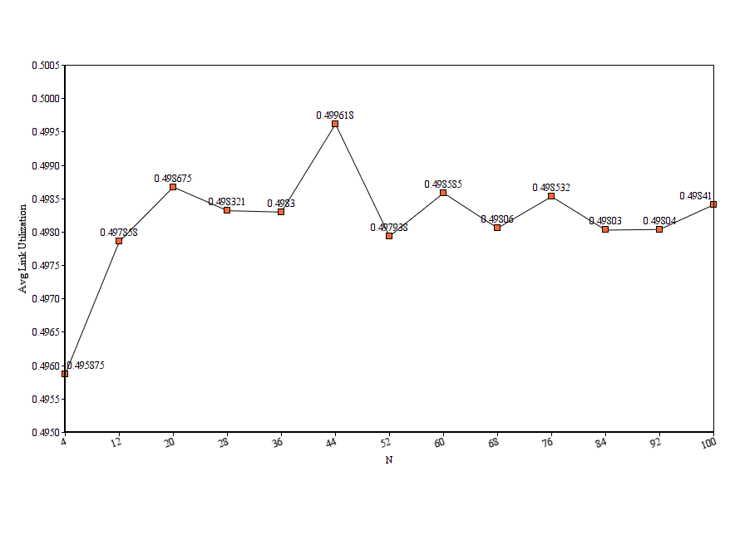

The average link utilization is initially increased then becomes more or less constant.
The graph shows spike because of less scale on Y axis.

For N=4, avg link utilization=0.49
For N=100, avg link utilization=0.49

It’s same as that was in B=2.

KOUQ: for B=4

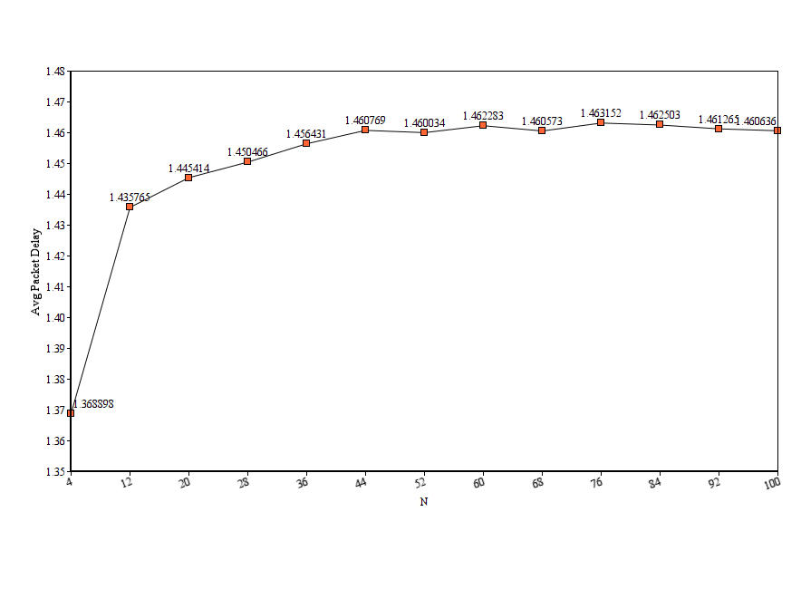

Here, the buffer size is changed from 3 to 4.
The average packet delay is increased with the increase in number of switch ports, but it becomes almost constant with higher values of N.

For N=4, avg packet delay=1.36
For N=100, avg packet delay=1.46

Similar to previous buffersize B=3.

KOUQ: for B=4

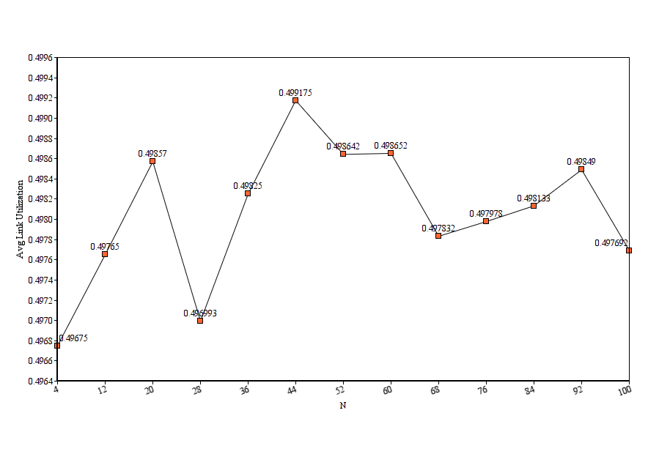

Here, for B=4, the average link utilization is more or less constant.
The graph shows spike because of very less scale on Y axis.

For N=4, avg link utilization=0.49
For N=100, avg link utilization=0.49

Again, similar to previous buffersize B=3.

All the values can be found in corresponding sample output files.
INQ_outputfile.txt and KOUQ_outputfile.txt

CONCLUSION

Thus, after observing all the graphs,
for B=2,3,4 and N=4 to 100 ,
the performance analysis can be done easily.

The avg packet delay is always increased with the increase in N, but for higher values, the change is very little.
Although, in INQ, with the increase in buffersize B, the avg packet delay gets increased.
But, in KOUQ, even with the increase in B, the packet delay remains almost constant.

It has been observed that the avg link utilisation remains as it is in all the cases, it doesn’t change much.

On varying K=0.6*N, 0.8*N, 1.0*N,
the pattern in increase of avg packet delay is same as we saw in previous graphs but especially for smaller values of N, the value of avg packet delay is increased with increase in knockout value.

and the avg link utilization undergoes no change and remain close to 0.49 for all the knockout values.

